**Setting Disaster Recovery for Azure VMs**

**Objective:** To create a disaster recovery for Azure virtual machines using a recovery

services vault

**Tools Required:** None

**Prerequisites:** None

Steps to be followed:

1. Enabling virtual machine replication

**Step 1: Enabling virtual machine replication**

1. Sign in to the Azure portal and search for **Virtual machines**

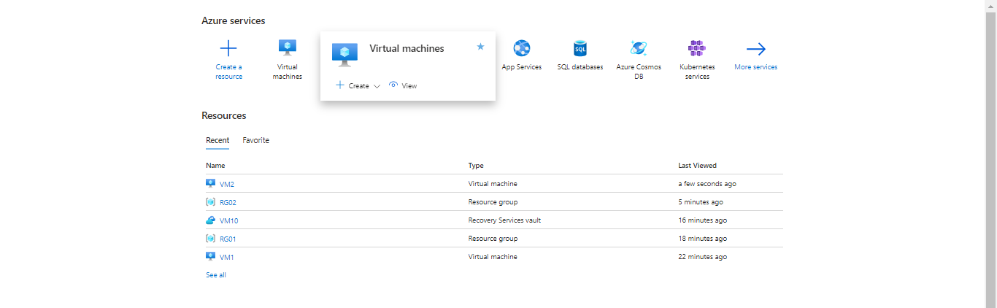

1. Click on **+ Create** and then select **Azure virtual machine**

1. In the **Basics** page enter the details as shown below and click on **Next: Disks >**

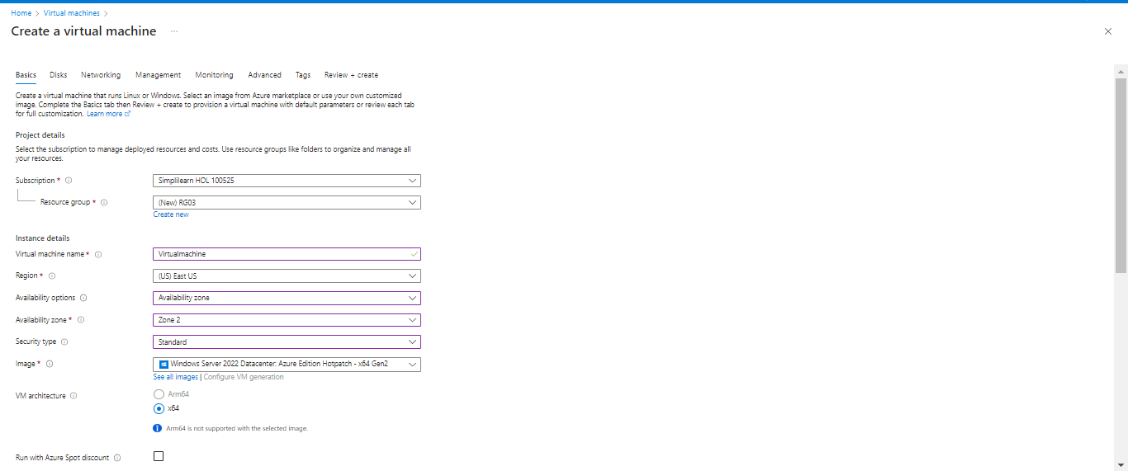

1. In the **Disks** page, enter the following details as shown below and click on **Review + create**

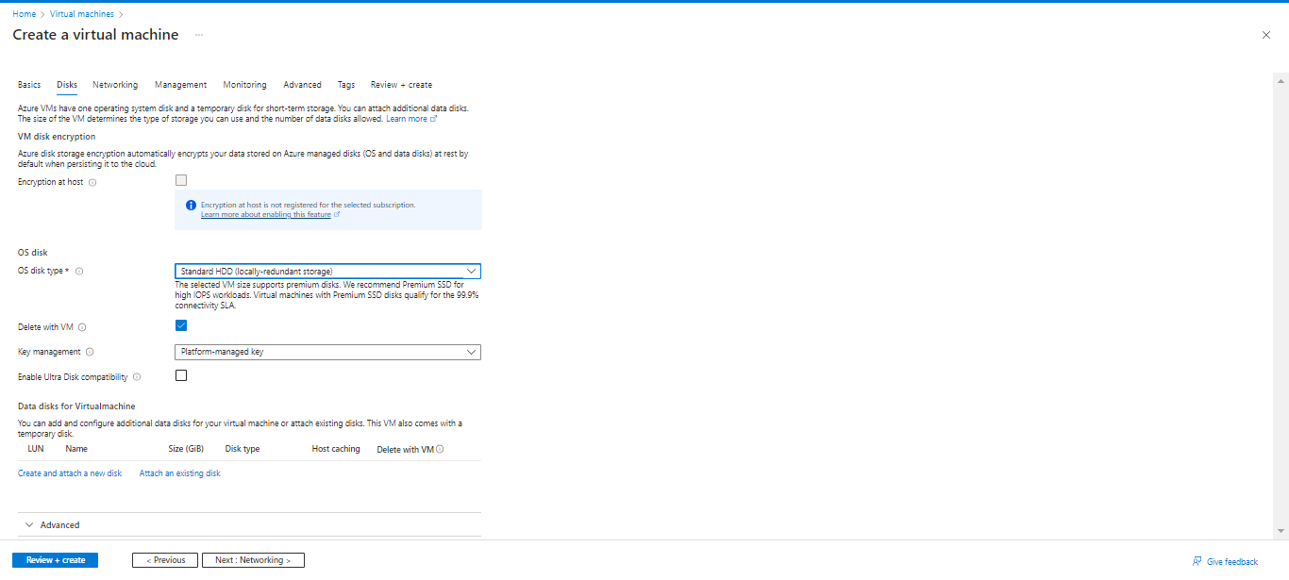

1. Then, click **Create**

The output appears as follows:

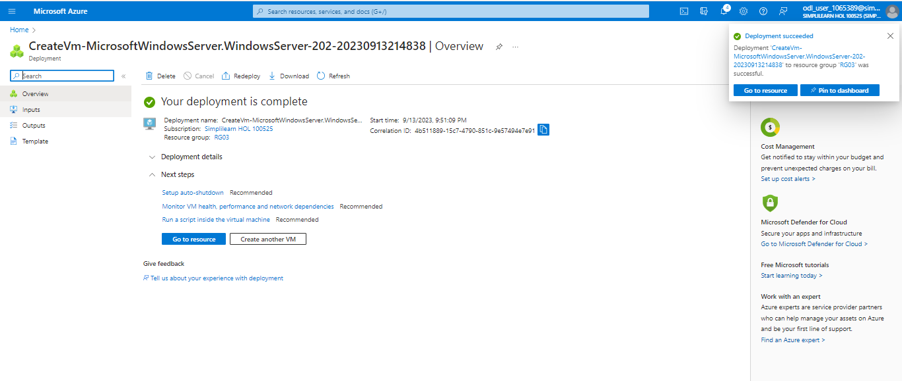

1. Search for **Recovery Services vaults** in the search bar

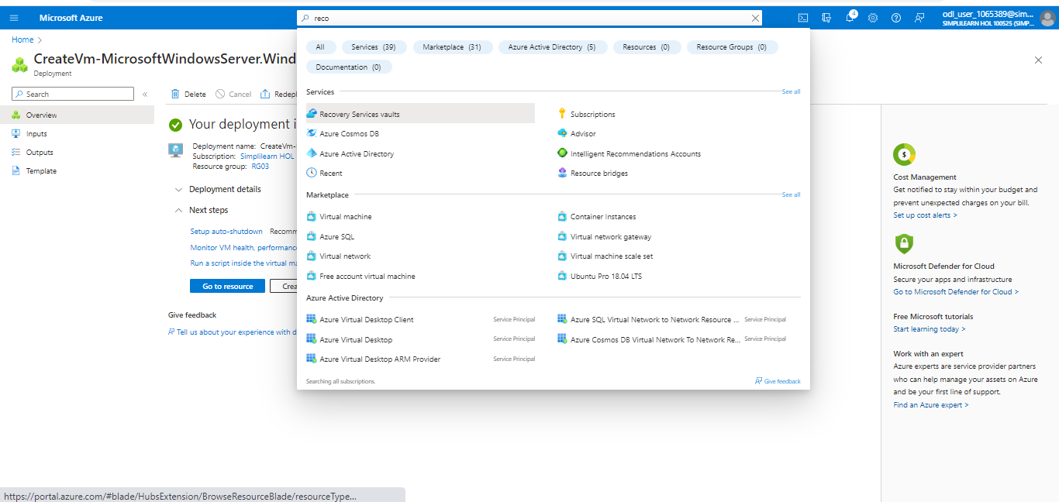

1. Click on **+ Create**

1. In the **Basics** page enter the following details as shown below and click on **Review + create**

1. Then, click on **Create**

1. After the deployment is completed, click on **Go to resource**

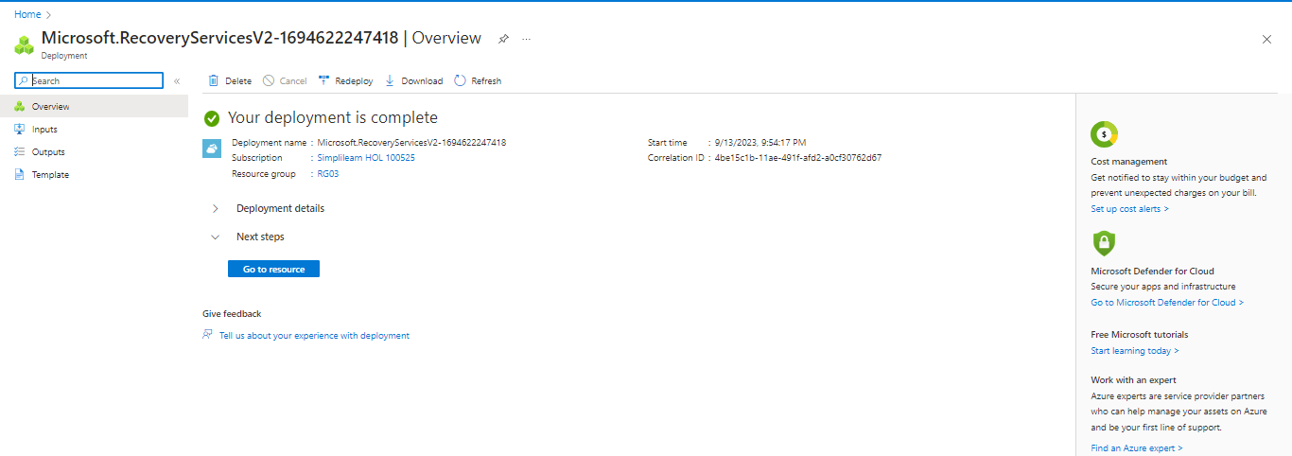

1. Click on **+ Enable Site Recovery**

1. In the **Basics** page enter the following details as shown below and click on **Review + create**

1. Then, click on **Create**

1. After the deployment is completed, click on **Go to resource**

1. Locate **Site Recovery** from the Overview

1. Click on **Site Recovery** andselect **Enable replication**

1. In the **Source** page enter the following details as shown below, click on **Next**

1. Select the **virtual machine** andclick on **Next**

1. In the **Replication settings** page enter the following details as shown below and click on **Next**

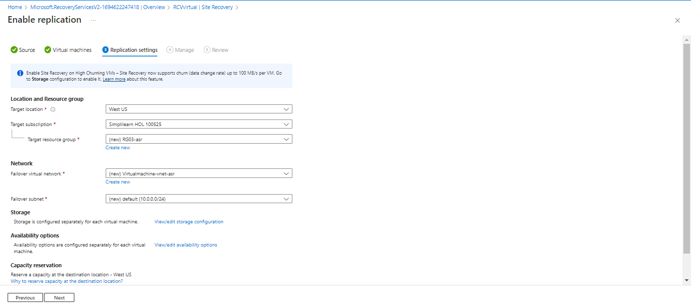

1. In the **Manage** page, enter the following details as shown below and then click on **Review**

1. Then, click on **Enable replication**

The following screen will appear:

The output appears as follows:

You have now successfully enabled VM replication and set up a disaster recovery solution for your Azure VMs, ensuring the continuity and availability of your virtual machines in the event of a disaster.